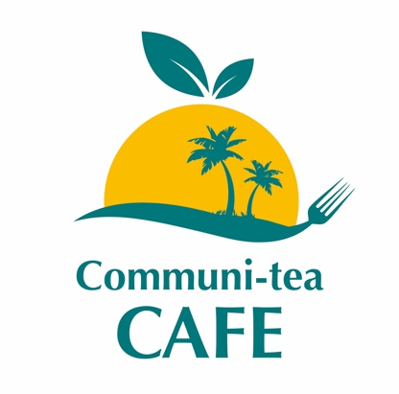

New Menu
please ask for daily availability
or specials.

Price List:
Breakfast:
Eggs, bacon, sausages, beans, slice of toast and tea £7.50
(add extra sausage, bacon and egg) £1 each
Bacon butty £3.50

Main meal £9.00. (Chicken meal £8.50)
Small meal £ 6.00

Chicken wings £ 4.00
Chicken portion £ 4.50
Fish portion £ 5.50
Chips £ 1.50
Patties (each) £ 2.00
Large Hot Dog £ 2.50
Soup £ 6.00
Side salad/ Coleslaw £ 1.50
Wraps £ 3.00
Fried Dumpling x1 £ 1.00
Cake portion £ 2.00

Drinks:
Bottles: £ 1.00
Juice £ 1.50
Can £ 1.00
Tea/Coffee £ 1.50
Milk (child cup) £ 0.50

